Web Design Examples

Landen Bailey

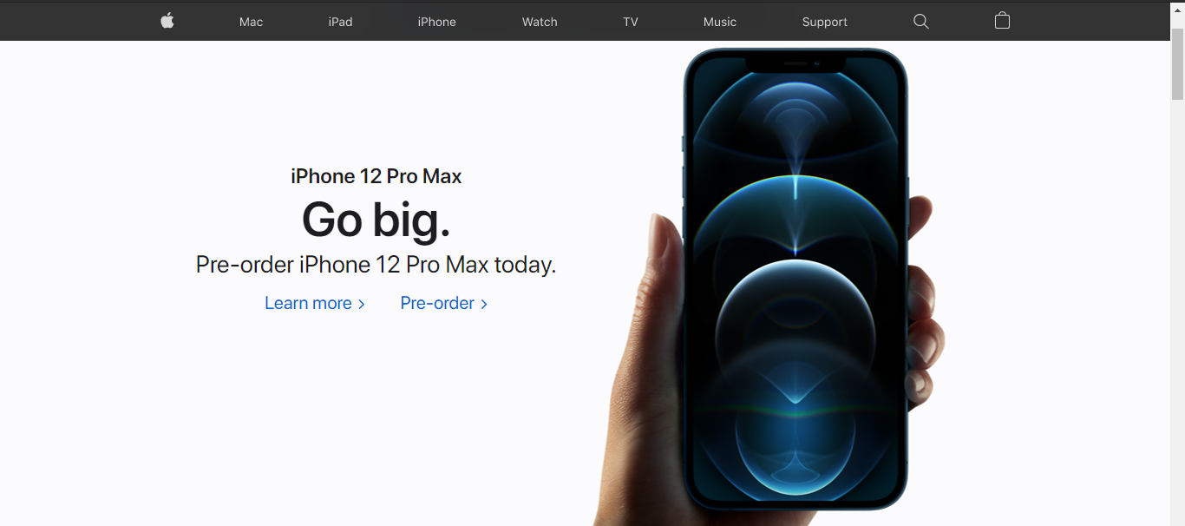Apple’s Website is one of the best examples of Wonderful Website design. It follows almost perfectly all of the principles of web design. Just evident in this screenshot, we see great use of white space and typography to draw the viewers attention to the words: Go big. And to the big picture itself. It also has a very easy to follow navigation bar at the top, and colors that coordinate wonderfully together.

Slack’s website also displays great website design principles. Coordinated animated graphics that don’t distract the visitor from the purpose of the page, a simple easy to use navigation bar, a very responsive design, and great uses of alignment on both text and graphics to direct the viewers eyes on long the visual hierarchy of the page, first to the welcome slides, then to the example graphic, then to the sign up buttons.

This website for the University of advancing technology need some help. It does some things fine… a good use of white space on the side, nice alignment, but it does a lot of things very wrong. The images seen are actually flashing obnoxiously at the viewers and take up way too much space. The is no obvious navigation through the website, I would have to search to find even what I want to click on, and it should lead me there itself.